INSTITUTE OF AERONAUTICAL ENGINEERING

(Autonomous)

Dundigal, Hyderabad-500 043

**Research Based Learning**

(Prototype / Design Building) External Evaluation Report

Title of your Idea : VIRTUAL MOUSE USING HAND GESTURE

Thrust Area / Sector : IMAGE PROCESSING AND PATTERN RECOGNITION

Branch : COMPUTER SCIENCE AND ENGINEERING

Year / Semester : 3rd year, 2nd semester

|  |  |  |  |  |
| --- | --- | --- | --- | --- |
| **S. No** | **Name of the Student** | **Roll Number** | **Mobile Number** | **Signature** |
| **1** | B. MOURYA | 19951A0596 | 8639042374 |  |
| **2** | N. NAGA SRAVANI | 19951A0598 | 7075171484 |  |
| **3** | T. NANDITHA | 19951A0584 | 9051112703 |  |
| **4** | P. KARTHIK | 19951A0569 | 9390165953 |  |

Team Members (Max. 4) : B. Mourya, N. Naga Sravani, T. Nanditha, P. Karthik

1. **Background of the Idea :**

In today's technological era, many technologies are evolving day by day. One such promising concept is Human- Machine Interface. For example, in a wired mouse there is no provision to extend limit. In wireless mouse, one should have Bluetooth hardware installed in the computer and Bluetooth dongle attached. The proposed technology will have no such limitations and will instead depend on gesture recognition. In this project, two technologies are mainly used: object detection, image processing. The aim is to move the mouse cursor on the screen without using hardware such as a mouse and only by moving the cursor through finger movements i.e., the process of gesture recognition. In this project, we present a novel approach for Human Computer Interaction (HCI) where cursor movement is controlled using a real-time camera. This project proposes a camera vision-based cursor control system, using hand gestures captured from a webcam. The system will allow the user to navigate the computer cursor using their hand bearing point-based lines and will be performed using different hand gestures. The proposed system uses nothing more than a low-resolution webcam that acts as a sensor and it is able to track the users hand bearing color point-based lines in two dimensions. The system is implemented using the python. The hand gesture is the most effortless and natural way of communication. The main objective of the preprocessing process is to transform the data into a form that can be more effectively and effortlessly processed. In the proposed work, the pre-processing techniques are created on the basis of different types of combinations from the subsequent hand gesture image processing operations such as capturing image, edge detection and these image processing methods. Initially, the hand gesture images are captured from the vision-based camera, The hand gestures can be observed with the different kind of interfaces that accurately records every abduction angle and position sensors for wrists. By this project we are aiming in creating a cost-free hand recognition software for laptops and PCs with a web-cam support. The project covers as a hand recognition tool which could be used to move the mouse pointer, perform simple operations like clicking and performing simple but fascinating operations that could be covered with the hand recognition.

1. **Problem Statement :**

A Computer Mouse is an input device that helps to point and to interact with whatever that is being pointed. There are so many types of mouse in the current trend, there’s the mechanical mouse that consists of a single rubber ball which can rotate in any direction and the movement of the pointer is determined by the motion of that rubber ball. There will always be limitations of the mouse as the mouse is a hardware input device and there can be some problems like mouse click not functioning properly. The mouse is a hardware device like any other physical object even the mouse will have a durability time within which is functional. After its durability time we have to change the mouse.

1. **Proposed Solution (Min 100 words):**

As the technology increase everything becomes virtualized. Such as speech recognition, Speech Recognition is used for recognition and translation of the spoken language into text. Thus, Speech Recognition can replace keyboards in the future, Similarly Eye Tracking which is used to control the mouse pointer with the help of our eye. Eye Tracking can replace mouse in the future. Gestures can be in any form like hand image or pixel image or any human given pose that require less computational difficulty or power for making the devices required for the recognitions to make work. Different techniques are being proposed by the companies for gaining necessary information/data for recognition handmade gestures recognition models. Some models work with special devices such as data glove devices and color caps to develop a complex information about gesture provided by the user/human.

1. **Technology concept formulation:**

The software Requirements in this project include: Python, Anaconda prompt, Spyder IDE, Modules (OpenCV, Mediapipe, Autopy). OpenCV (Open-Source Computer Vision Library) is an open-source BSD-licensed library that includes several hundreds of computer vision algorithms. MediaPipe Hands is a high-fidelity hand and finger tracking solution. It employs machine learning (ML) to infer 21 3D landmarks of a hand from just a single frame. Hand Landmark Model is as follows, After the palm detection over the whole image our subsequent hand landmark model performs precise key point localization of 21 3D hand-knuckle coordinates inside the detected hand regions via regression, that is direct coordinate prediction. The model learns a consistent internal hand pose representation and is robust even to partially visible hands and self-occlusions.

1. **Prototype of proposed system (UI screens / block diagrams / circuits / designs):**

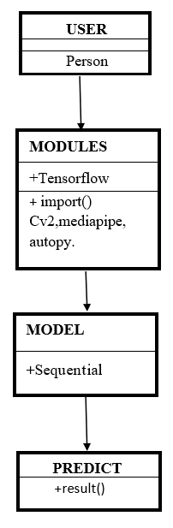

**Class diagram**

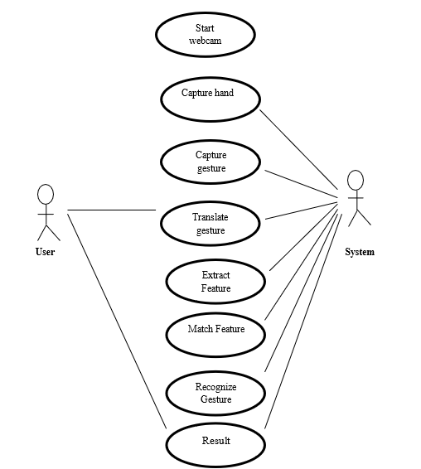

## Use case diagram

## gesture image.png

## System architecture

1. **Detailed description of prototype / product / project :**

In this project an effective hand gesture segmentation technique has been proposed based on the preprocessing, edge detection techniques. Pre-processing is defined as procedure of formulating data for another process. The main objective of the preprocessing process is to transform the data into a form that can be more effectively and effortlessly processed. In the proposed work, the pre-processing techniques are created on the basis of different types of combinations from the subsequent hand gesture image processing operations such as capturing image, edge detection and these image processing methods. Initially, the hand gesture images are captured from the vision-based camera, The hand gestures can be observed with the different kind of interfaces that accurately records every abduction angles and position sensors for wrists. By this project we are aiming in creating a cost-free hand recognition software for laptops and PCs with a web-cam support.

The project covers as a hand recognition tool which could be used to move the mouse pointer, perform simple operations like clicking and performing simple but fascinating operations that could be covered with the hand recognition. Hand Gesture Recognition plays a key role in human-computer interactions. As we can see that there are so many new Technological advancements happening such as biometric authentication which we can see frequently in our smart phones, similarly hand gesture recognition is a modern way of human computer interaction i.e., we can control our system by showing our hands in front of webcam and hand gesture recognition can be useful for all kinds of people. Based upon this idea this paper is presented. This paper provides a detailed explanation to the algorithms and methodologies for the color detection and virtual mouse.

In the existing system, A Computer Mouse is an input device that helps to point and to interact with whatever that is being pointed. There are so many types of mouse in the current trend, there’s the mechanical mouse that consists of a single rubber ball which can rotate in any direction and the movement of the pointer is determined by the motion of that rubber ball. Later the mechanical mouse is replaced by the Optical Mouse. Optical Mouse consists of a led sensor to detect the movement of the pointer.

Years Later the laser mouse was introduced to improve the accuracy and to overcome the drawbacks of the Optical Mouse. Later as the Technology has been increased drastically wireless mouse was introduced so as to enable hassle free movement of the mouse and to improve the accuracy. No Matter how much the accuracy of the mouse increases but there will always be limitations of the mouse as the mouse is a hardware input device and there can be some problems like mouse click not functioning properly ad etc., as the mouse is a hardware device like any other physical object even the mouse will have a durability time within which is functional and after its durability time, we have to change the mouse.

As a result, a window will pop up on the screen of the user displaying the hands of the user and the sub ordinates lines controlling the cursor the output can be shown by the command cv2.imshow("Webcam", img); other than only showing the camera input window the user also provided with additional information such as additional and appropriate sources of light in the background which will help the user in setting the surroundings right.

The system architecture that has been proposed will completely change the way people would use the computer system. Presently, the webcam, microphone and mouse are an integral part of the computer system. This project will completely eliminate the necessity of mouse. This would lead to a new era of Human Computer Interaction (HCI) where no physical contact with the device is required. Gesture recognition gives the best interaction between human and machine. Gesture recognition is also important for developing alternative human computer interaction modalities. It enables human to interface with machine in a more natural way. Gesture recognition can be used for many applications like sign language recognition for deaf and dumb people, robot control.

1. **Final version of prototype / product (only images):**

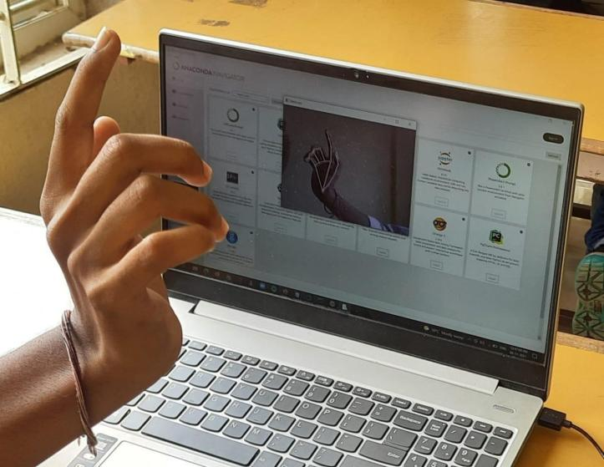

Dean-CLET Dean -TIIC